HDFC Bank Ltd – Credit Intelligence & Control

Vendor Profiling Report applicable for – *************

Category of Sub Assayer – Sub Assayer of *********
Initiated Date: 09-09-2026
Completed Date: 10-09-2026
1.General information
Vendor to be empaneled : Kumarasen
Product : Gold Loan
Nature of business : Gold assayer
Address with PIN Code ; No 17/8-1 chinnaeara kali street, korainadu, Mayiladuthurai - 609001
Phone Nos. / Mobile : 8903204590 / 6374436213
Email ID : Nil
Type of set up : NA
Name of Proprietor : Kumarasen

2. Office verification
Date and time of visit : 10-09-2026 / 02.04 PM
Contacted person : Kumarasen - applicant

Area of the office : 100 SQFT
Independent or a Residence-cum office : NA
Infrastructure Details: (To be mentioned as well furnished or partially furnished or not furnished)
* Furniture : Yes
* Telephones : No
* Fax : No
* Computers : No
* AC : No
* Internet : No
* Cabins/Cubicles : No
Business activity : NA
Approx value of stocks : NA
Office name board : (Sighted / Not seen, If seen, Name depicting to be mentioned)
Manpower : NA
No of years in business : NA
Office : NA
Neighbour check and confirmation:
*******************

Office Locality
i) Posh Upper Class Middle Class Lower Middle-Class Slum
ii) Commercial Housing Complex Small/Medium Shops Market Area Other.

Work experience & Business details of the Vendor

Previous Experience : NA

Profile/Goodwill : NA

Fraud History : NA

Police Verification : NA

Prior terminations : NA

Additional Information
PAN details of the Vendor : ********
Bank Account details : *******

Reference Check Details :
REFERENCE 1 : ****************

REFERENCE 2: ****************

Final Remarks of residence and office verification

RESIDENCE PROFILE VERIFICATION: Address: (No 17/8-1 chinnaeara kali street, korainadu, Mayiladuthurai - 609001). It is an Rc house, with an approximate area of 500 sq. ft approx/-. We met the applicant, Mr. Kumarasan, as confirmed that he is residing at the given address for the past 6 month in a Rental house. The family consists of 03 members. During the visit, neighbour Kathiravan also confirmed the same details. Status: Positive.

BUSINESS PROFILE VERIFICATION:
We had visited the given address with applicant guidance (No:7 VM complex Vandikara steet Mayilduthurai - 609001), Met Kumarasan applicant and he is confirmed that the given concern running for the past 36 years. It is Rental, Rc building area around nearly 100 Sqft approx. It is a Proprietorship concern. NOB Gold smith. No Name board. No Staff. We cross-checked with the neighbour Vignesh and confirmed the same details this case as Positive.

3. Details and residence verification (Proprietor/ Partner/ Director as applicable)

Name of the Proprietor/ Partner/ Director : Kumarasen

DOB & Qualifications : 07/11/1970 & 8 th
Residence Address with PIN : No 17/8-1 chinnaeara kali street, korainadu, Mayiladuthurai - 609001
Name board : (Sighted - No)
Date and time of visit : 10-09-2026 / 01.46 PM

Person contacted during visit : Kumarasen – Applicant
Ownership Status : (Owned/ Rented/ Leased House to be mentioned)
Marital status & Family Structure : Married & Family member – 03
Years in current residence : 6 months
Years in city : 10 YEARS

Observations

Type of Residence | Locality of Residence | - Housing Complex  - Small/ Medium Shops  - Market Area  - Other
- Independent House  - Flat  - Slum  - Hutment  - Chawl  - Small unit within house  Area : _700______ sq ft | - Posh  - Upper Middle Class  - Middle Class  - Lower Middle Class  - Under-developed Area  - Slum  - Commercial Area

Construction | Exterior | Interior
- Pukka  - Semi-Pukka  - Temporary  - Brick Walled  - Plastered | - Good  - Average  - Poor  - Lift Present (Y/N)  - Watchman Present | - Good  - Average  - Poor

Interior Conditions | Durables Owned | Vehicles Owned | Income Group
- Painted  - Furnished  - Carpeted  - Curtains  - Clean | - TV  - AC  - Fridge  - Music System  - Sofa | - Two Wheelers:  - Cars: | - HIG  - MIG  - LIG

Neighbour/ TPC check:

Name of Neighbor: Kathiravan, Vignesh
TPC Rremarks:
RESIDENCE PROFILE VERIFICATION: Address: (No 17/8-1 chinnaeara kali street, korainadu, Mayiladuthurai - 609001). It is an Rc house, with an approximate area of 500 sq. ft approx/-. We met the applicant, Mr. Kumarasan, as confirmed that he is residing at the given address for the past 6 month in a Rental house. The family consists of 03 members. During the visit, neighbour Kathiravan also confirmed the same details. Status: Positive.

BUSINESS PROFILE VERIFICATION:
We had visited the given address with applicant guidance (No:7 VM complex Vandikara steet Mayilduthurai - 609001), Met Kumarasan applicant and he is confirmed that the given concern running for the past 36 years. It is Rental, Rc building area around nearly 100 Sqft approx. It is a Proprietorship concern. NOB Gold smith. No Name board. No Staff. We cross-checked with the neighbour Vignesh and confirmed the same details this case as Positive.

Risk Alerts and other details : NA

Other check remarks – (To be carried out at the time of visit and mentioned in the below format)

SR NO | POLICY NORMS | YES | NO |  | - | -
1.A | ASSAYER AGE TO BE 30 YRS | Y | N | Applicant Age *********** | - | -
 | (PROOF OF DOB FROM PAN CARD / PASSPORT / VOTER ID/ DRIVING LICENSE) | Y | N | Pan Card | - | -
 |  |  |  |  | - | -
2.A | HAS A SHOP (INDEPENDENT / RESIDENCE CUM RETAIL OULET) | Y | N |  | - | -
2.B | INVOLVED IN JOB WORK ONLY | Y | N |  | - | -
3 | SHOULD HAVE 05 YRS EXPERIENCE IN GOLD JEWELLERY BUSINESS | Y | N | Applicant having 7 years of experience. | - | -
4.A | ASSAYER TO GIVE REFERENCE CHECK OF SOMEONE WHO HAS PERMANENT RESIDENCE IN SAME LOCALITY FOR REFERENCE CHECK | Y | N |  | - | -
4.B | OBTAIN PERMANENT RESIDENTIAL ADDRESS OF THE ASSAYER & HIS PARENTS | Y | N |  | - | -
5 | PAN CARD OF THE ASSAYER | Y | N | ********* | - | -
6 | RESIDING AT THE SAME LOCATION FOR AT LEAST 03 YEARS | Y | N | Residing for the past 4 yrs. | - | -
 | VALIDATED FROM (RENT AGREEMENT / MAINTENANCE RECEIPT/ RENT RECEIPT) | Y | N |  | - | -
7 | CIBIL CHECK TO BE POSITIVE (TO BE DONE BY RIC) | Y | N | Score *****, ***** | - | -
8 | TWO WHEELER / FOUR WHEELER (NOT MANDATORY) | Y | N |  | NA | NA
9 | STANDARD OF LIVING (NOT IN A SLUM LOCALITY OR NEGATIVE AREAS AS DEFINED IN OUR PL POLICY) | Y | N |  | N
9.A | MARKET REPUTATION | Y | N
10 | KYC DOCUMENT OF THE SUB ASSAYER | + | - |  | - | -
 | COMMENT :

4.Dedupe Check Status (To be carried out at the Bank and incorporated in the report)
Outcome of SAS check :
Outcome of CIBIL check :
Outcome of internal dedupe check :
5.Document verification : Pan Card No. ******** was verified with an online check positive.

6.Summary
Office Profile/ Verification Status :
Residence Verification Status :
Previous Work Experience Check Status : NA
Vendor Reference Status : NA
Documents verification status :
OVERALL STATUS : Positive
RESIDENCE PHOTOS:
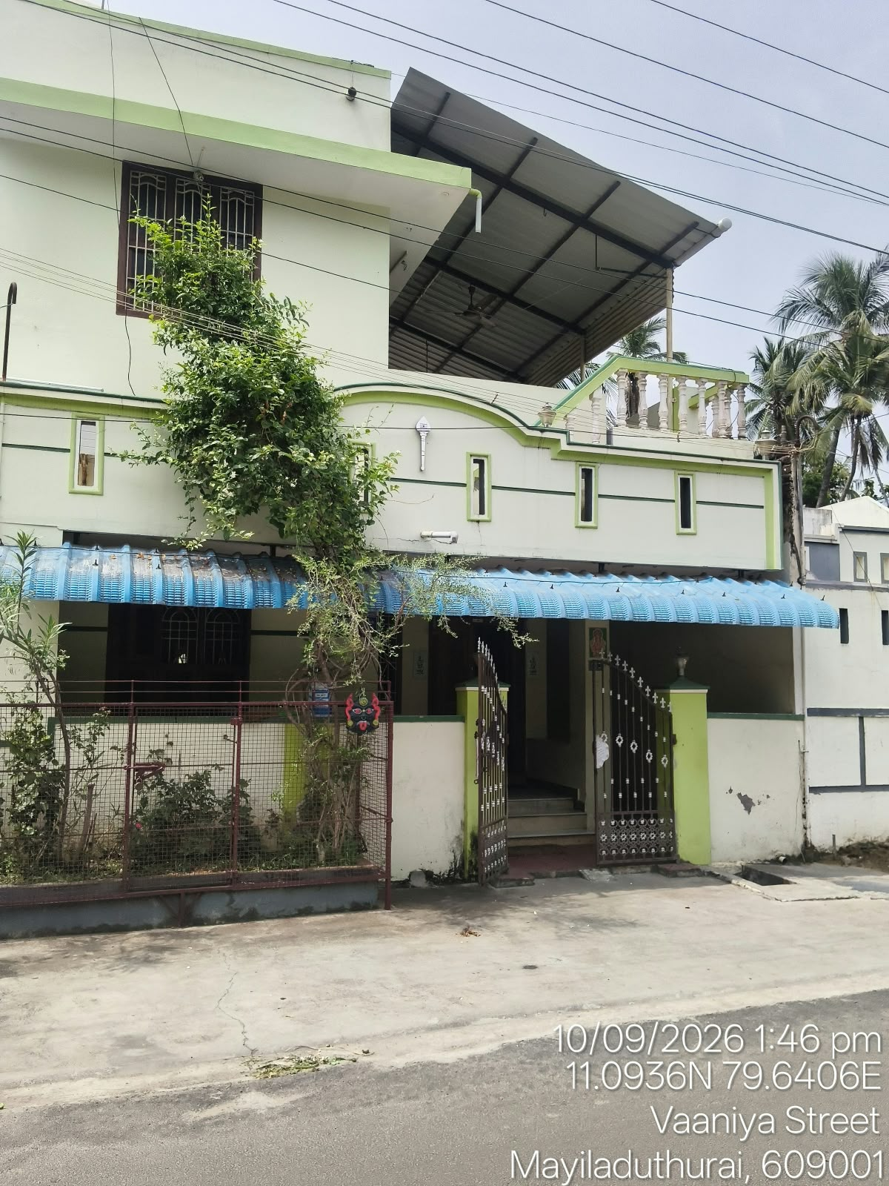
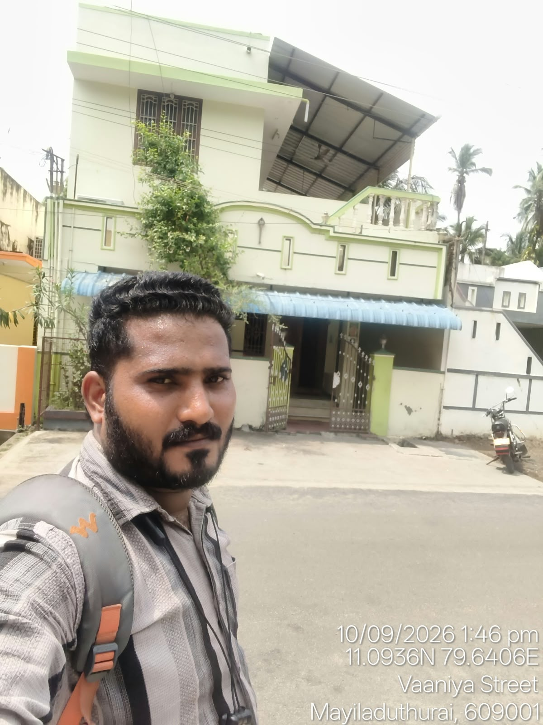

BUSINESS PHOTOS;

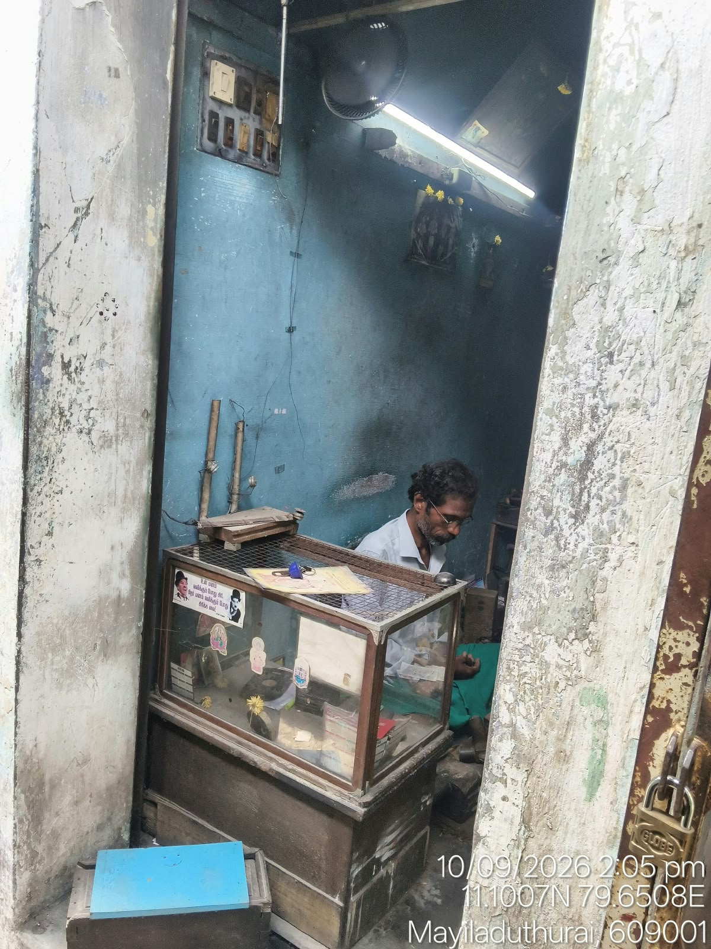
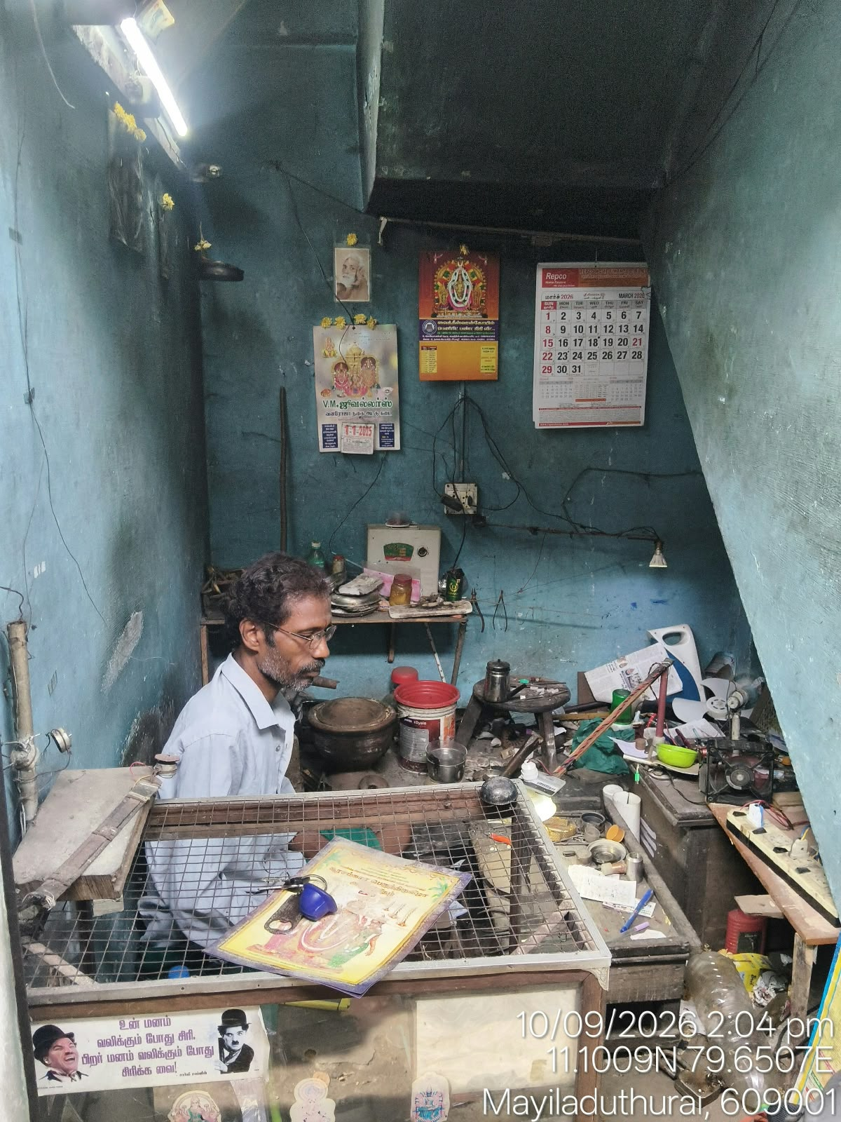
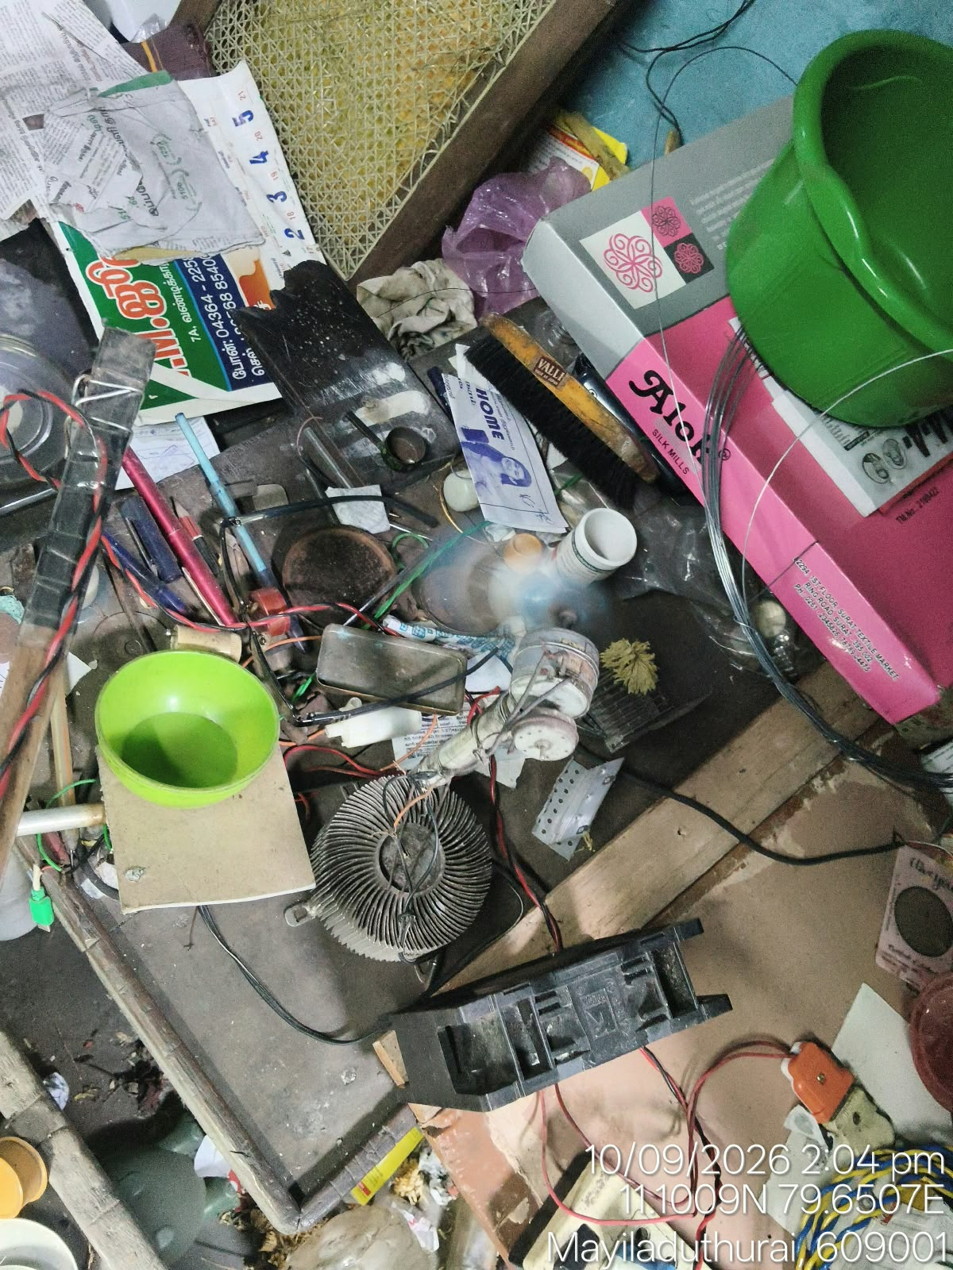
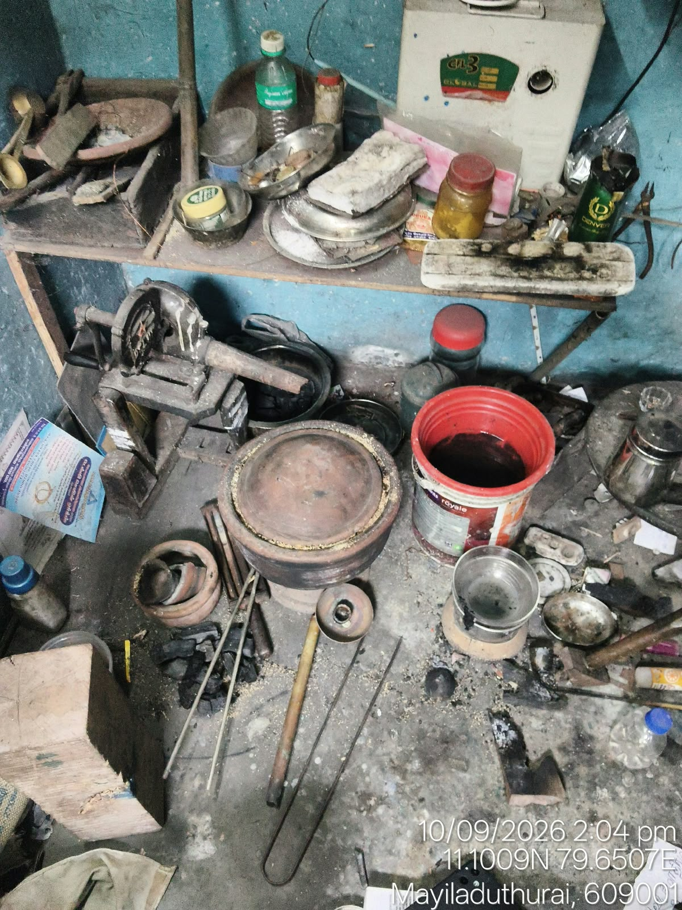
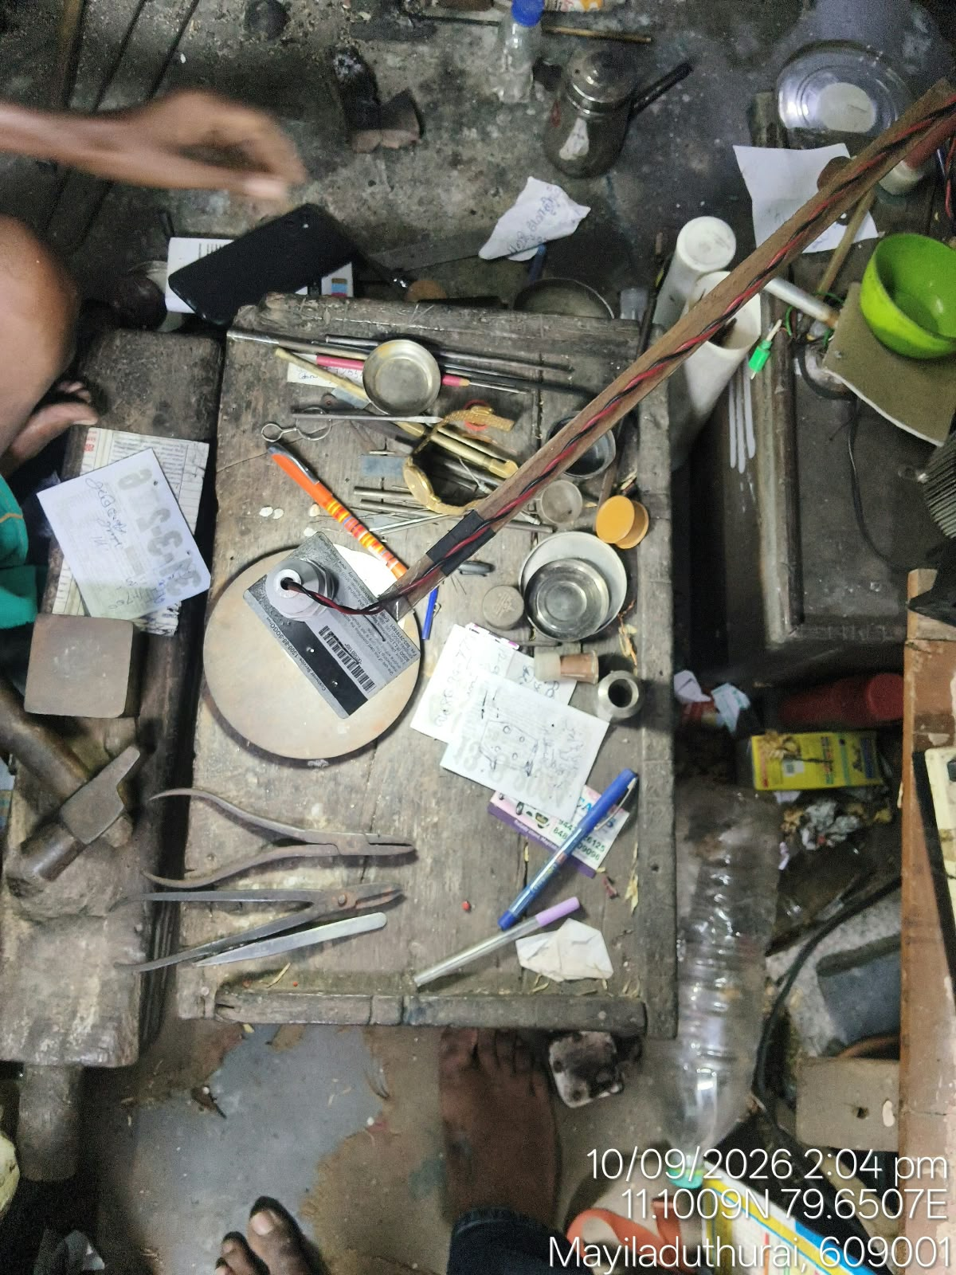
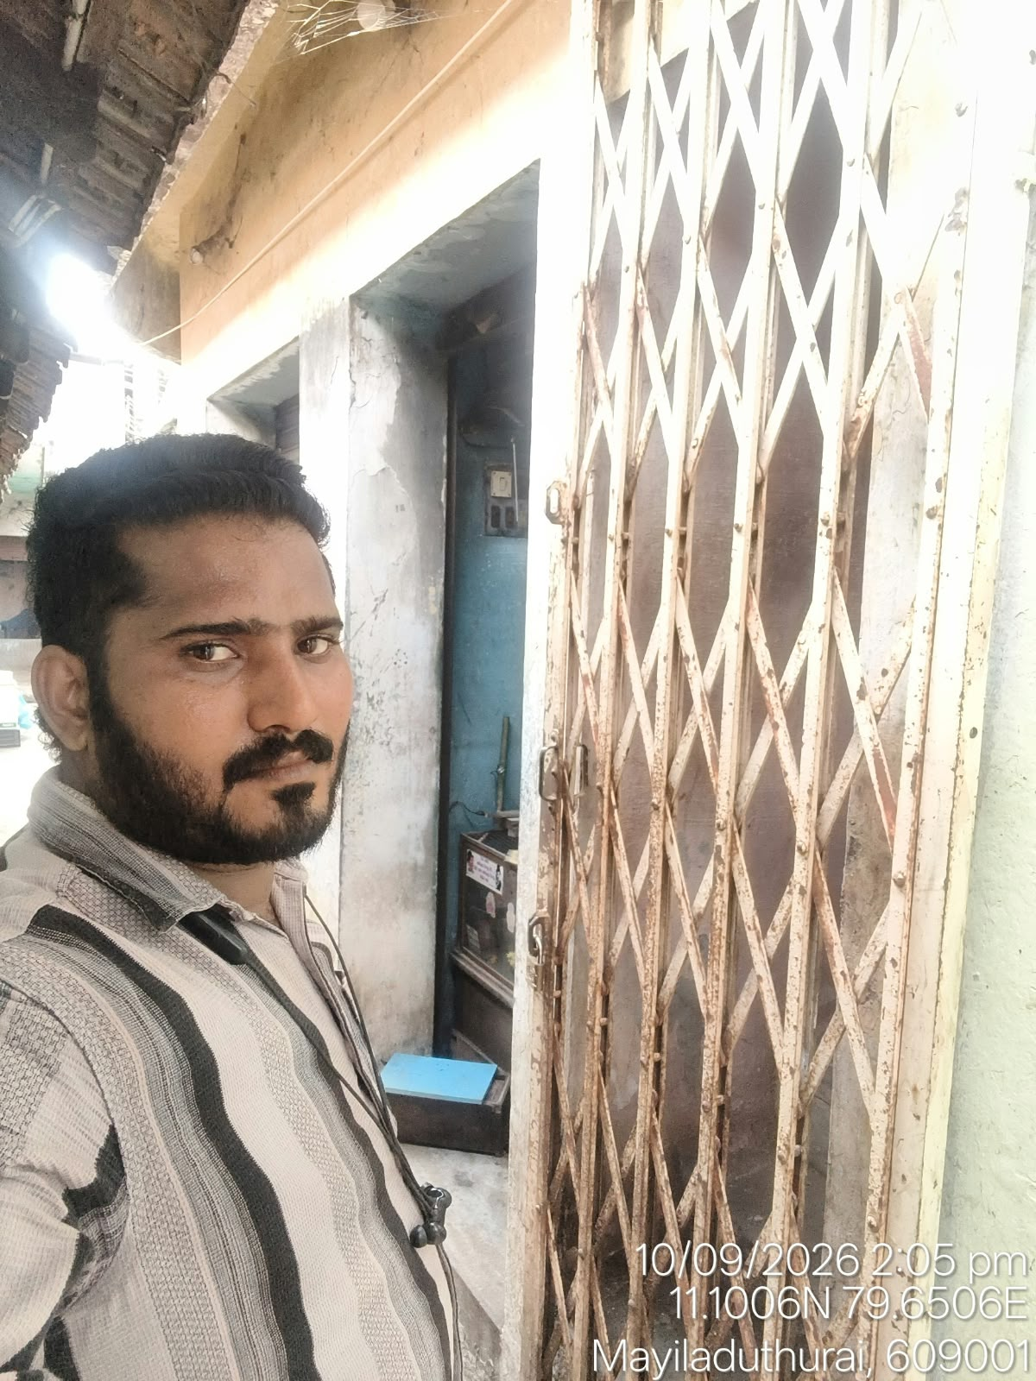

CIC CHECK CONDUCTED BY: REVIEWED BY:

Date: 10-09-2026 Verifier Name: Marimuthu

Signature and Seal of Agency



